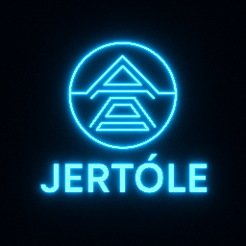

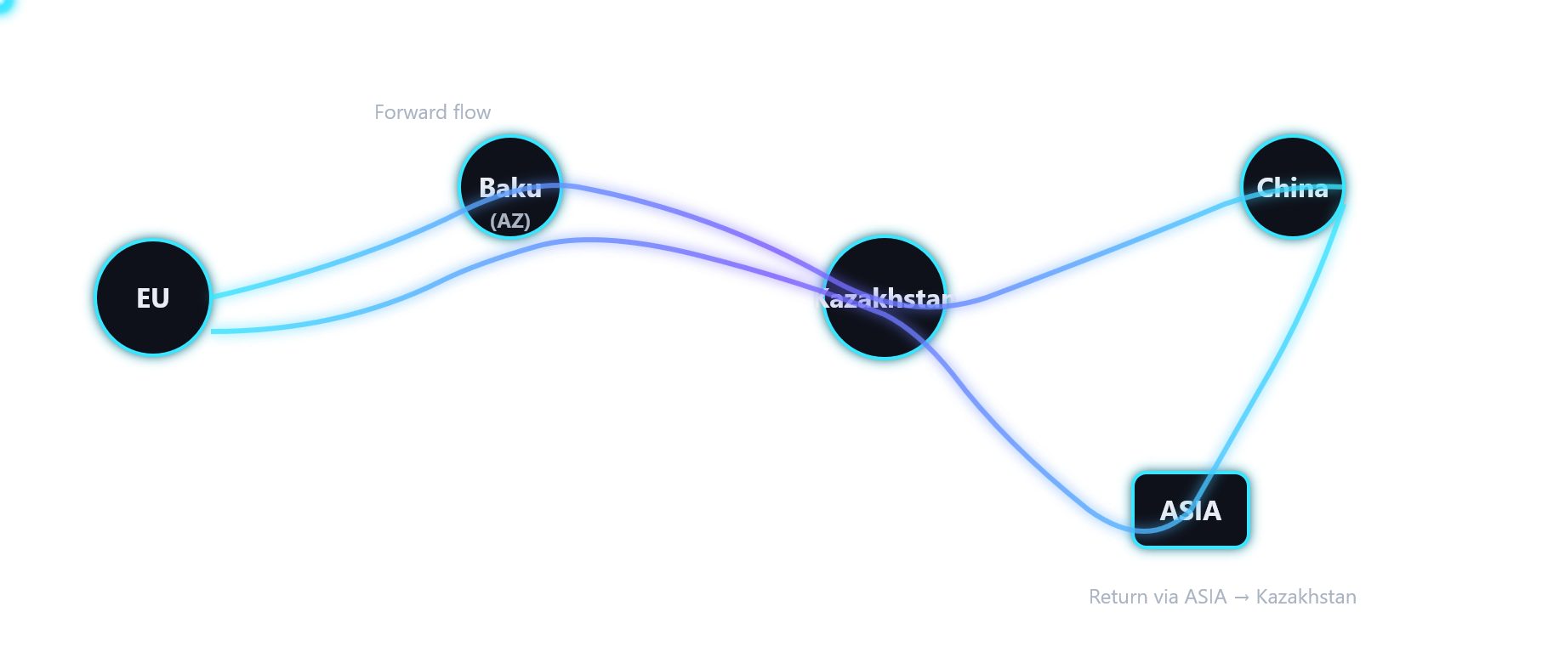

JERT Utility Token Whitepaper – Enhanced Regulatory Version

Introduction

JERT is a utility token created for the Green Cold Energy Network across Eurasia, operated by TOO Cryogas (Cryogas Kazakhstan). This whitepaper outlines the technical, legal, and infrastructural foundations of the JERT ecosystem, strengthened to meet expectations of the Ministry of Digital Development of Kazakhstan and AIFC regulatory frameworks.

Total Emission

The total and immutable emission is fixed at 1,000,000,000,000 JERT tokens (1 trillion). No additional minting is possible under any circumstances.

Tokenomics

JERT is not a security and does not grant ownership, voting, or dividend rights.
Distribution:
- 50% Infrastructure & Ecosystem Reserve
- 50% Market & Community Allocation

Locked treasury and transparent multi‑signature governance apply.

Allocation

• 50% — Corporate reserve (Cryogas Kazakhstan)
• 20% — Infrastructure development (LNG/LCNG terminals, cold storage, logistics)
• 10% — Market liquidity & staking
• 10% — Team & governance
• 10% — Strategic partners & onboarding

Infrastructure Layers

JERT derives its utility from industrial infrastructure operated by Cryogas Kazakhstan:
1. Cold energy & storage access
2. Logistics & B2B terminal services
3. LCNG / LNG / CNG fueling
4. Energy services (BTU/BOG loop)
5. Settlements with suppliers & contractors
6. Payroll & incentive systems (optional, compliant)

6. Middle Corridor Eurasia

The ecosystem is built around the Middle Corridor (TITR), connecting China–Kazakhstan–Caspian–Caucasus–Türkiye–EU. Cryogas terminals form a unified “Green Cold Energy Network across Eurasia”, supporting cold‑energy recovery, logistics, LCNG infrastructure, and modular data centers.

7.Wallet Classes

Class A — Corporate treasury
Class B — Partners & suppliers
Class C — Public utility users

8.Token Use Cases

• Contractor settlements (up to 30%)
• Optional salary payments
• International supplier payments
• Terminal access & cold‑energy fees
• LCNG and B2B services

9. Technical Architecture

JERT operates on an EVM‑compatible blockchain with minimum five (5) VPS validator nodes.
API Layer integrates:
- ERP/WMS/TMS systems
- LCNG metering
- SCADA/IoT cold‑storage
- KYC/AML providers

Real‑time token settlement is linked to physical service delivery.

10.Governance

Governance is anchored by Cryogas Kazakhstan with:
- transparent reporting,
- multi‑signature treasury control,
- ESG compliance,
- independent audits.

11. Legal & Compliance

Fully aligned with Kazakhstan digital‑asset law and AIFC requirements:
- fixed supply,
- transparent circulation,
- immutability of issuance,
- KYC/AML where applicable,
- full accounting traceability.

This version is strengthened for Ministry review and AIFC compliance.

12. Priorities

1. Infrastructure deployment
2. Transparent treasury use
3. Compliance‑first growth
4. Demand‑driven token utility

Appendices

A. Corporate structure
B. Kazakhstan regulatory summary
C. Risk factors
D. Technical glossary
E. Smart contract audit (pending)

Annex F – AML/KYC Framework

JERT follows a compliance-first framework aligned with:
- Ministry of Digital Development of Kazakhstan AML rules
- AIFC AML/KYC Framework
- FATF recommendations (where applicable)

AML/KYC Components:
1. Identity verification for partners, suppliers, and major users
2. Risk scoring system for counterparties
3. Transaction monitoring integrated through API Layer
4. Suspicious activity reporting workflow
5. Compliance officer oversight (Cryogas Kazakhstan)
6. Record keeping (minimum 5 years)

Annex G – Infrastructure Evidence Pack
The utility of JERT is directly backed by physical and digital Cryogas infrastructure:

1. LNG/LCNG Terminal Architecture
- Modular LCNG station
- Cryogenic tanks and pumps
- LNG cold-energy recovery loops (BTU/BOG)

2. Cold Storage & Freezing
- Industrial cold chambers
- Cryogenic energy recovery coils
- B2B warehouse modules (20,000 m² expansion zone)

3. B2B Logistics Terminal
- Container handling
- Rail access (350 m unloading zone planned)
- Re-export zone linked to the Middle Corridor

4. Digital & API Layer
- ERP/TMS/WMS integration
- Blockchain–industrial bridge API
- Real‑time metering from LCNG dispensers

5. Evidence Types (included upon request):
- Layouts (DWG/PDF)
- Master plan of the Cryogas terminal
- Infrastructure photos and engineering diagrams
- Power and cold-energy balance sheets
- Regulatory permits and approvals (when issued)

